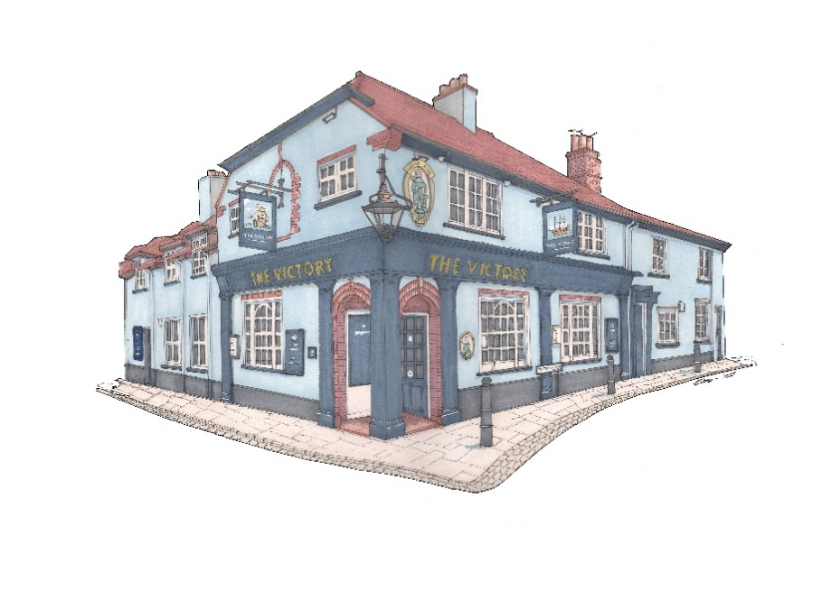

**Small plates £9**

Crab & coriander fishcakes, sweet chilli (GF)

Sautéed king prawns, chilli & garlic (GF)

Smoked salmon, pickled cabbage, sesame, soy dressing (GF)

Squid Provençal (GF)

Beef carpaccio, parmesan, watercress (GF)

Chargrilled asparagus, confit peppers, parmesan (V) (GF)

New Zealand green lip mussels, garlic, parmesan *

Deep fried camembert, cranberry (V)

**Small plates £8**

French onion soup, cheese croute (V) *

Hot chorizo, toast *

Smoked mackerel pate, toast

Chipolatas, sesame & soy

Smoked chicken goujons, sweet chilli (GF)

Cod goujons, tartare sauce (GF)

Tenderstem broccoli tempura, soy dressing (V)

Sauté wild mushroom, toast, garlic & truffle oil (V)

***Signature Dishes***

Chargrilled sirloin steak, sauté potatoes, wild mushrooms, tomatoes & garlic butter (GF)

**£30**

Seared tuna loin, cumin spiced ratatouille & roast vine tomatoes (GF)

**£25**

Roast haunch venison, fondant potato, swede purée & juniper Jus (GF)

**£24**

Stuffed peppers, couscous & salsa Verde (V) (GF)

**£17**

**Please advise your server of any food allergies or intolerances.**

**\* Gluten free option available \***